1. WAP to print a Reverse of a given number.

import java.util.Scanner;

public class ReverseNumber {

public static void main(String[] args) {

Scanner scanner = new Scanner(System.in);

System.out.print("Enter a number: ");

int number = scanner.nextInt();

int reversedNumber = 0;

while (number != 0) {

int digit = number % 10;

reversedNumber = reversedNumber \* 10 + digit;

number /= 10;

}

System.out.println("Reversed number: " + reversedNumber);

scanner.close();

}

}

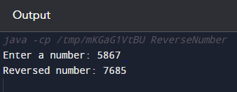

1. Write a program in java to demonstrate usage of Primitive data types – Boolean,Char,Byte,Short,Int,Long,Float and Double

import java.util.Scanner;

public class PrimitiveDataTypesDemo {

public static void main(String[] args) {

// Boolean

boolean isJavaFun = true;

System.out.println("Is Java fun? " + isJavaFun);

// Char

char grade = 'A';

System.out.println("My grade is: " + grade);

// Byte

byte age = 25;

System.out.println("My age is: " + age);

// Short

short numberOfStudents = 1000;

System.out.println("Number of students: " + numberOfStudents);

// Int

int population = 1000000;

System.out.println("Population: " + population);

// Long

long worldPopulation = 7800000000L; // Note the 'L' suffix for long literals

System.out.println("World population: " + worldPopulation);

// Float

float pi = 3.14159f; // Note the 'f' suffix for float literals

System.out.println("Value of pi: " + pi);

// Double

double e = 2.71828;

System.out.println("Value of Euler's number: " + e);

}

}

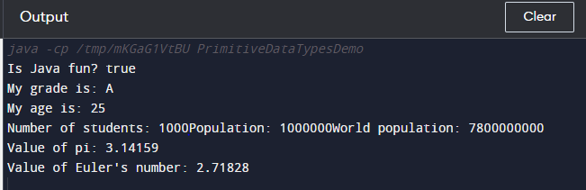

1. WAP in java to swap two numbers using temporary variable.

import java.util.Scanner;

public class SwapNumbers {

public static void main(String[] args) {

// Declare and initialize two numbers

int num1 = 5;

int num2 = 10;

System.out.println("Before swapping:");

System.out.println("num1 = " + num1);

System.out.println("num2 = " + num2);

// Swap the numbers using a temporary variable

int temp = num1;

num1 = num2;

num2 = temp;

System.out.println("After swapping:");

System.out.println("num1 = " + num1);

System.out.println("num2 = " + num2);

}

}

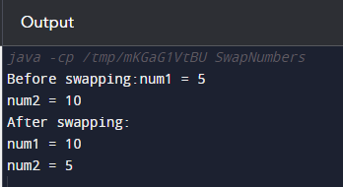

1. WAP in java to check weather the given number is positive or negative.

import java.util.Scanner;

public class CheckPositiveNegative {

public static void main(String[] args) {

Scanner scanner = new Scanner(System.in);

System.out.print("Enter a number: ");

int number = scanner.nextInt();

if (number > 0) {

System.out.println("The number is positive.");

} else if (number < 0) {

System.out.println("The number is negative.");

} else {

System.out.println("The number is zero.");

}

scanner.close();

}

}

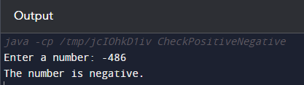

1. WAP in java to demonstrate using instance/class variable in a java program by creating a simple public class

import java.util.Scanner;

public class VariableDemo {

static int classVariable = 10;

int instanceVariable = 20;

public static void main(String[] args) {

VariableDemo instance1 = new VariableDemo();

VariableDemo instance2 = new VariableDemo();

instance1.instanceVariable = 30;

instance2.instanceVariable = 40;

System.out.println("Class variable: " + VariableDemo.classVariable);

System.out.println("Instance 1 variable: " + instance1.instanceVariable);

System.out.println("Instance 2 variable: " + instance2.instanceVariable);

}

}

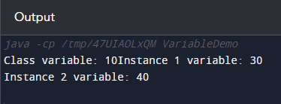

1. Demonstrate the java class using getter setter method for accessing private data members.

import java.util.Scanner;

public class Person {

private String name;

private int age;

public Person(String name, int age) {

this.name = name;

this.age = age;

}

public String getName() {

return name;

}

public void setName(String name) {

this.name = name;

}

public int getAge() {

return age;

}

public void setAge(int age) {

this.age = age;

}

public void displayInfo() {

System.out.println("Name: " + name);

System.out.println("Age: " + age);

}

public static void main(String[] args) {

Person person = new Person("Ansh", 30);

System.out.println("Name: " + person.getName());

System.out.println("Age: " + person.getAge());

person.setName("Sasha");

person.setAge(25);

System.out.println("\nUpdated information:");

person.displayInfo();

}

}

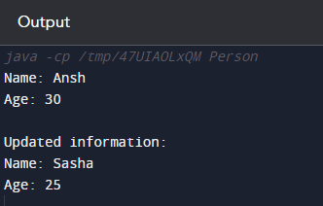

1. Demonstrate the use of static variable in java.

import java.util.Scanner;

public class StaticVariableDemo {

static int staticVar = 0;

public StaticVariableDemo() {

staticVar++;

}

public static void main(String[] args) {

StaticVariableDemo instance1 = new StaticVariableDemo();

StaticVariableDemo instance2 = new StaticVariableDemo();

StaticVariableDemo instance3 = new StaticVariableDemo();

System.out.println("Static variable value: " + StaticVariableDemo.staticVar);

}

}

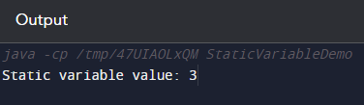

1. Demonstrate the use of static method in java.

import java.util.Scanner;

public class StaticMethodDemo {

static void printMessage() {

System.out.println("This is a static method.");

}

public static void main(String[] args) {

StaticMethodDemo.printMessage();

StaticMethodDemo instance = new StaticMethodDemo();

instance.printMessage();

}

}

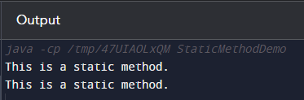

1. Demonstrate the use of scanner class for taking Input/Output from user in java.

import java.util.Scanner;

public class ScannerInputOutputDemo {

public static void main(String[] args) {

Scanner scanner = new Scanner(System.in);

System.out.print("Enter your name: ");

String name = scanner.nextLine();

System.out.print("Enter your age: ");

int age = scanner.nextInt();

System.out.println("Hello, " + name + "! You are " + age + " years old.");

scanner.close();

}

}

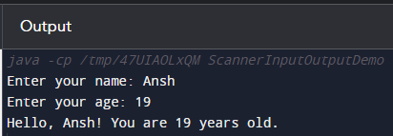

1. Create a program in java to create a class box with private members as length,breath,height. Create two methods getdimension(),setdimension() to set and get values. Create instances of this class to call the methods.

import java.util.Scanner;

public class Box {

private double length;

private double breadth;

private double height;

public Box(double length, double breadth, double height) {

this.length = length;

this.breadth = breadth;

this.height = height;

}

public void getDimensions() {

System.out.println("Length: " + length);

System.out.println("Breadth: " + breadth);

System.out.println("Height: " + height);

}

public void setDimensions(double length, double breadth, double height) {

this.length = length;

this.breadth = breadth;

this.height = height;

}

public static void main(String[] args) {

Box myBox = new Box(5.0, 3.0, 2.0);

System.out.println("Initial Box Dimensions:");

myBox.getDimensions();

myBox.setDimensions(6.0, 4.0, 3.0);

System.out.println("\nUpdated Box Dimensions:");

myBox.getDimensions();

}

}

